Link: https://github.com/Tgt1985/csd-340.git

Github Repository:
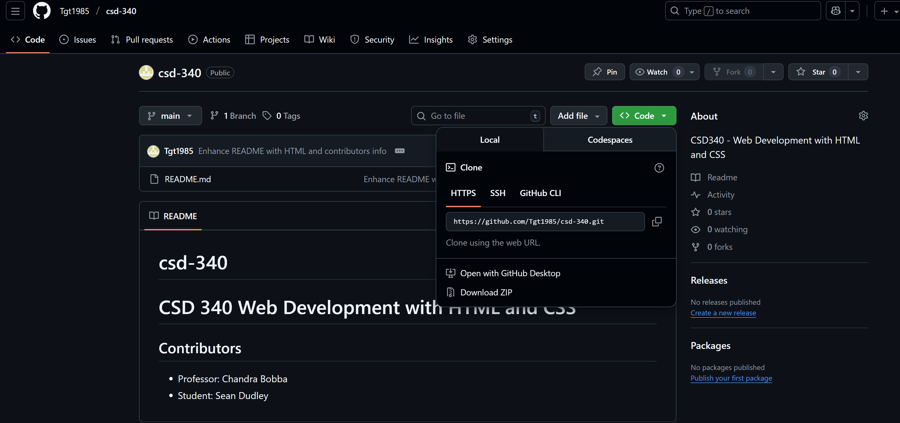
Local Directory:

